**Montessori Reading Program LINKS & RESOURCES**

Questions? Email Audrey Frazier: audrey@aastorage.com

**Teaching the Sounds**

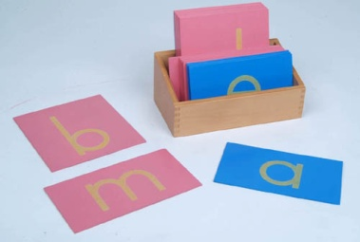

* Sandpaper Letters or
* Tactile Letters (salt, felt, glitter glue, puffy paint, etc.)

TO PURCHASE SANDPAPER LETTERS:

<http://www.montessorioutlet.com/cgi-bin/category.cgi?&category=5104> Traditional Sandpaper letters from Montessori Outlet $24.95

<http://www.montessorioutlet.com/cgi-bin/item/510400040/5104/Montessori-Outlet-Box-for-the-Sandpaper-Letters> Box for Traditional Sandpaper letters from Montessori Outlet, $8.95

TO MAKE WITH 3D MATERIAL OF YOUR CHOICE

<https://docs.google.com/viewer?a=v&pid=explorer&chrome=true&srcid=0B-Jp2xvcHjp4ODU2ZjA1MjUtYjdjZi00MGE5LTg1ZDctNjk3MjFlMTAzNDg4&hl=en_US> Letter Wall Charts. Colored lowercase alphabet cards, ready to print on white cardstock to make homemade Sandpaper Letters.

<http://www.montessorimaterials.org/Language/printlower.pdf> Black lower case alphabet cards ready to print on colored cardstock for homemade Sandpaper Letters. (Pink/red paper for consonants, light blue paper for vowels)

<http://montessorimom.com/sandpaper-letters/> Solid color background lowercase alphabet cards ready to print on white cardstock for homemade sandpaper letters.

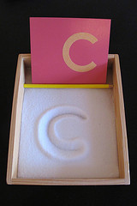

* Salt Tray

An extension of the Sandpaper Letters activity. Flat container with salt for tracing the letters.



* Tracing Letters

An extension of the Sandpaper Letters activity. Child traces *inside* the bubble letter 6 times - one with each of 6 rainbow colored pencils (red, orange, yellow, green, blue, purple) PDF document is uploaded and posted on [www.aastorage.com/school/notes.htm](http://www.aastorage.com/school/notes.htm)

* [Initial Sound Cards](http://unitedteaching.com/blog/?p=320)

**[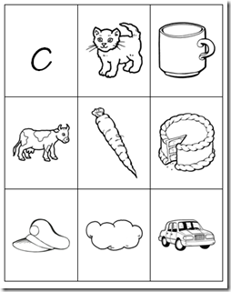](http://lh3.ggpht.com/_CVvUspwsuKw/TJ8-PtUJh4I/AAAAAAAAC2M/vmGPmHrrfPU/s1600-h/image%5b7%5d.png) [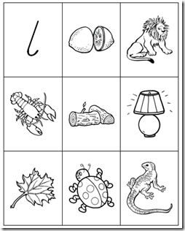](http://lh5.ggpht.com/_CVvUspwsuKw/TJ8-RqvriyI/AAAAAAAAC2U/U3zZUuZ4E8Q/s1600-h/image%5b8%5d.png)**

<http://unitedteaching.com/blog/?cat=17&paged=2>

PDF file. Print vowel cards on light blue paper and consonants on pink paper. Put in sheet protectors in 3 ring binder. $5.95 for PDF.

**Moveable Alphabet**

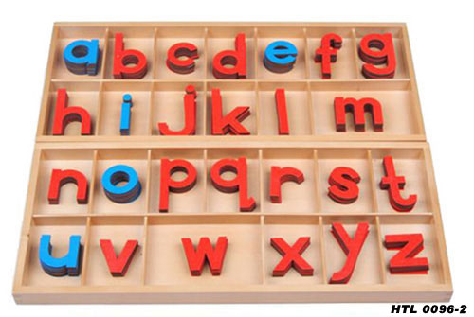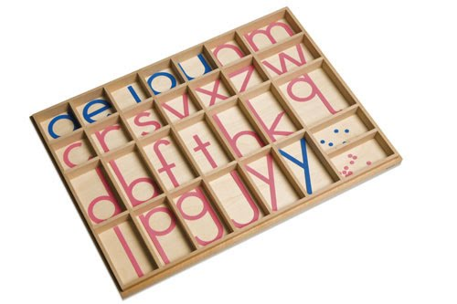

<http://www.montessorioutlet.com/cgi-bin/item/510400090/5104/Montessori-Outlet-Small-Movable-Alphabet-%28Print%2C-Mix-Blue-%26-Red%29> Traditional Moveable Alphabet from Montessori Outlet, $16.95

<http://www.montessorioutlet.com/cgi-bin/item/510400350/5104/Montessori-Outlet-Small-Movable-Alphabet-Box-%28Lower-Case-Letters%29> Box for traditional Moveable Alphabet from Montessori Outlet, $16.95

<http://www.montessorimaterials.org/Language/MovableAlphabet.pdf>

Free Printable Moveable Alphabet Cards to print on cardstock and laminate. You would still need to find a tackle box in which to organize the cards. I bought one at Walmart for around $8.

**Metal Insets for Design**

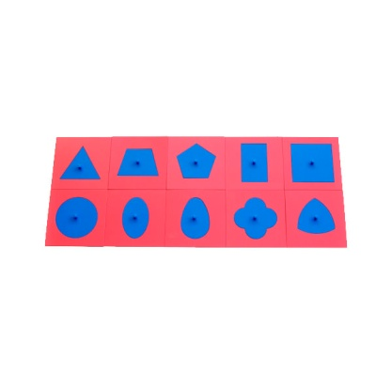

<http://www.montessorioutlet.com/cgi-bin/item/510400400/5104/Montessori-Outlet-Metal-Insets> Metal Insets (Insets for Design) from Montessori Outlet,

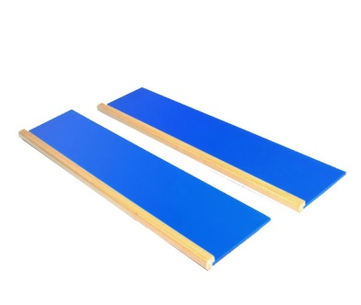[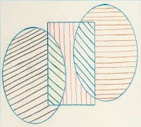](http://3.bp.blogspot.com/_Ct_JwowbbCk/S5L6HvdUKuI/AAAAAAAABtg/mEZheBP_tjg/s1600-h/metal+insets.jpg)

<http://www.montessorioutlet.com/cgi-bin/item/510400410/5104/Montessori-Outlet-Metal-Insets-Stands>

Metal Inset stands from Montessori Outlet, $27.95

<http://www.practical-homeschooling.org/2008/09/template-metal-insets/> Template for making homemade Metal Insets of Design using a rigid material of your choice.

**Pink and Blue Reading Series**

**OBJECTS:**

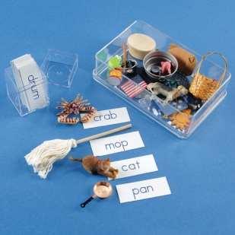 <http://montessorimom.com/phonetic-word-list/>

Lists of phonetic words. Helpful if you want to make your own reading materials. Also provides ideas for objects to collect for Pink and Blue Reading steps 1 and 3.

<http://www.montessoriservices.com/language/early-reading-activities/phonetic-object-box-1> Phonetic object box from Montessori Services. 30 assorted objects and word cards to use with Pink and Blue Reading steps 1 and 3. $27.95

<http://montessori-n-such.com/detail.aspx?ID=1352> Objects from Montessori-n-Such

L2400K Two & Three Letter Short Vowel Object Set A - collection of 20 attractive objects (for Pink Reading). $13.99

L2401K Four Letter Short Vowel Object Set A - collection of 15 appealing objects (for Blue Reading). $13.99

<http://www.gluesky.com/2010/05/making-montessori-objects-for-reading/> Make your own objects out of modeling clay. Adorable, but a lot of work!

[](http://www.google.com/imgres?q=yellow+star+icon&um=1&hl=en&sa=N&biw=1224&bih=840&tbm=isch&tbnid=xGcZoseEQPRbtM:&imgrefurl=http://www.clipartguide.com/_search_terms/yellow_star.html&docid=nZ6gXes708IEOM&imgurl=http://www.clipartguide.com/_thumbs/1386-0903-2403-2925.jpg&w=100&h=99&ei=CbU-T-SWHMG-2gWJxu2cCA&zoom=1)I personally have never bought a prepackaged object set, but think it would not be a bad idea. I have collected objects over time, a little here and a little there. I am always on the lookout for new phonetic objects! Barbi accessories work well, as do Playmobil pieces. Ebay sometimes sells bags of miscellaneous Barbi pieces. Dollar stores, thrift store toy bins, your own children’s toy box, and the family office junk drawer are all good places to start.

Examples of objects for Pink Reading:

bud, a bud from a fake flower

pot, a mini black cauldron pot from a Halloween party favor

web, a mini plastic spider web from a Halloween party favor

nut, a real whole walnut

bed, a Fisher Price little yellow plastic bed

egg, a fake egg (Dollar Tree has lots of cute little eggs right now)

hat, I stole the hat off of my kids’s Woody action figure from Toy Story.

peg, just a wooded peg from an old coat hook board

box, a cute little box wrapped with wrapping paper

red, a square of red felt

fan, a mini fan I made with a rectangle of scrapbook paper, wrapped at the bottom with string

cap, a fire fighters cap and also a baseball cap, both from my kids’s toy box

bag, a Barbi bag

log, a mini Lincoln log

pin, a large cute pink diaper pin

pan, a Barbi pan

top, a cute toy top

ram, a toy animal

tug, a tugboat

tub, a mini metal tub

Pronunciation guide: no vowel sound after consonants (“d” not “duh”)

Short vowel sounds, hard consonant sounds, every letter of the word must be represented with an individual sound.

PDF PAPER FILES

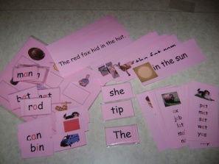

<http://thehelpfulgarden.blogspot.com/search/label/Language%20Arts>

Pink and Blue Reading series. Free. This website has step-by-step picture guides along with the PDFs.

<http://www.practical-homeschooling.org/2009/10/montessori-pink-level-available-for-free/>

Pink Reading Series. Free

**Green Reading Series, Phonograms**

<http://montessorimom.com/phonogram-words/>

Lists of words with phonograms

***NOTE: ALL PHONGRAM LINKS ARE TO PDF’S PURCHASABLE THROUGH MONTESSORI PRINT SHOP. IN A MONTH OR SO, [www.thehelpfulgarden.blogspot.com](http://www.thehelpfulgarden.blogspot.com) WILL HAVE POSTED A FULL GREEN READING SERIES FOR FREE.

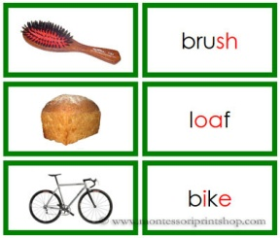 <http://www.shop.montessoriprintshop.com/Green-Phonogram-Word-and-Picture-Cards-Set-1-Real-Pictures-LF-3ap.htm> Green Phonogram Word and Picture Cards - ***Set 1***-Real Pictures, from Montessori Print Shop. Includes 12 sets of phonograms: sh, ee, oa, or, ai, ow, ch, i-e, ea, oo, a-e, er. PDF $2.49

# Phonogram Words and Real Pictures ( set 2) - Printable Montessori Learning Materials for home and school. <http://www.shop.montessoriprintshop.com/Green-Phonogram-Word-and-Picture-Cards-Set-2-Real-Pictures-LF-3bp.htm> Green Phonogram Word and Picture Cards - *Set 2* - Real Pictures, from Montessori Print Shop. Includes 12 sets of phonograms: o, y, e, ow, ar, qu, th, ay, o-e, ph, aw, o. PDF $3.49

# Green Phonogram Sentence Cards - Montessori Green Phonogram Language Series for Montessori Learning at home and at school. <http://www.shop.montessoriprintshop.com/Green-Phonogram-Sentence-Cards-LF-3c.htm>

# Green Phonogram Sentence Cards PDF $2.99

# Green Phonogram Cards Set 1 - Montessori Green Phonogram Language Series for Montessori Learning at home and at school. <http://www.shop.montessoriprintshop.com/Green-Phonogram-Cards-Set-1-LF-15a.htm> Green Phonogram Cards - *Set 1.* 44 Word Lists with picture on top. $2.79

# Green Phonogram Cards Set 2 - Montessori Green Phonogram Language Series for Montessori Learning at home and at school. <http://www.shop.montessoriprintshop.com/Green-Phonogram-Cards-Set-2-LF-15b.htm>

# 33 Word Lists with Picture on top. $2.49